Enrolment No - 22030400176

Name - sonu kumar

Collage - ASOIT (CE)

Model 2

MY project name -:Green Living Rewards Program: Users earn rewards for adopting eco-friendly habits and practices

Check Figma -:

https://www.figma.com/file/jtpOVe3cuj41LCbiE3uvD9/WT-Assigmen t?type=design&node-id=0%3A1&mode=design&t=DVm7qtiBQpLxD

FJb-1

1 Home page

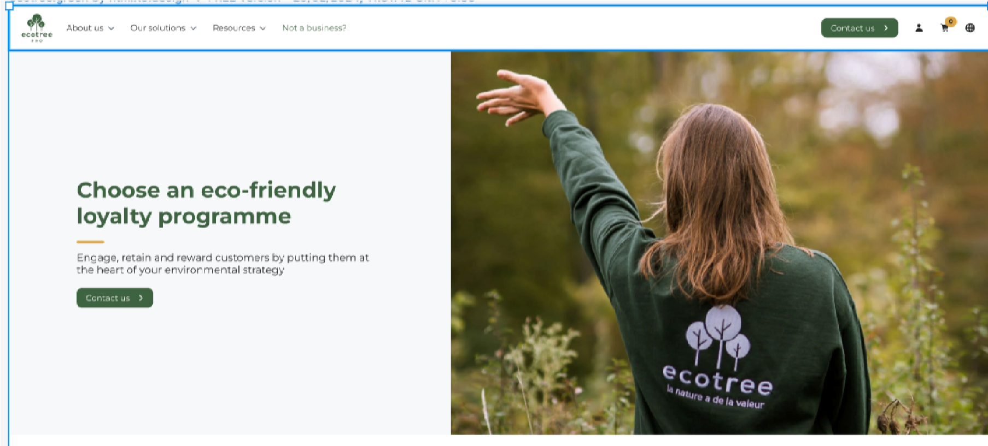

**Tailor-made loyalty solutions for your customers**

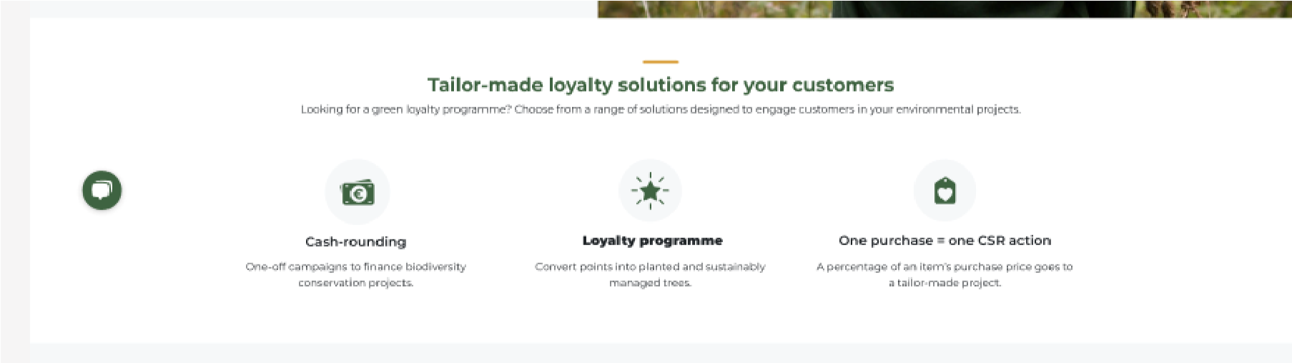

**We can help you pick the perfect loyalty**

**Solution**

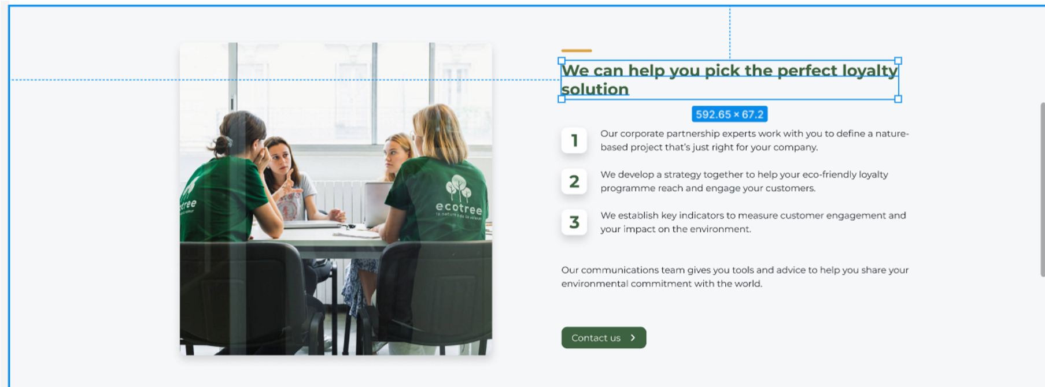

**Discover customer loyalty programmes developed with our partners**

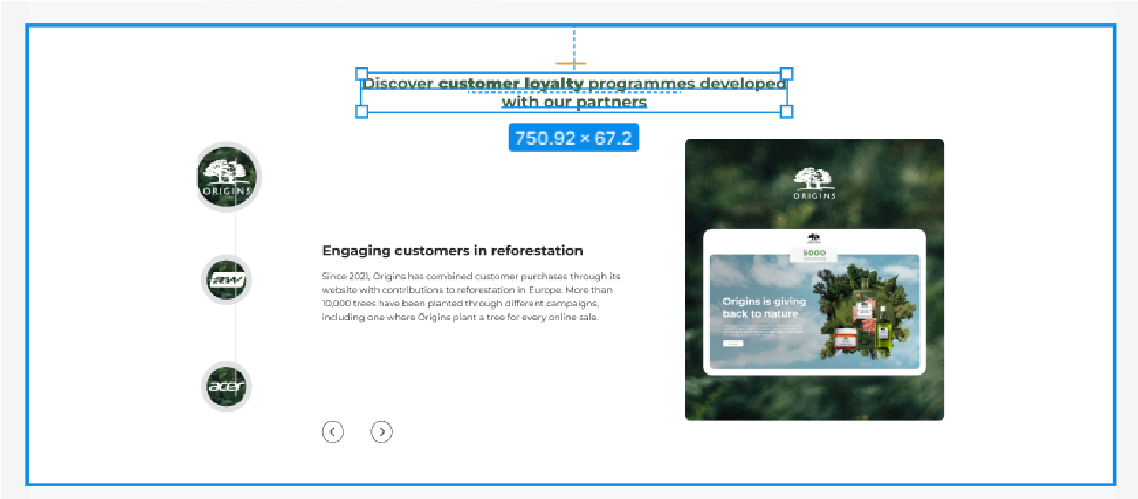

**How to share your eco-responsible values with customers**

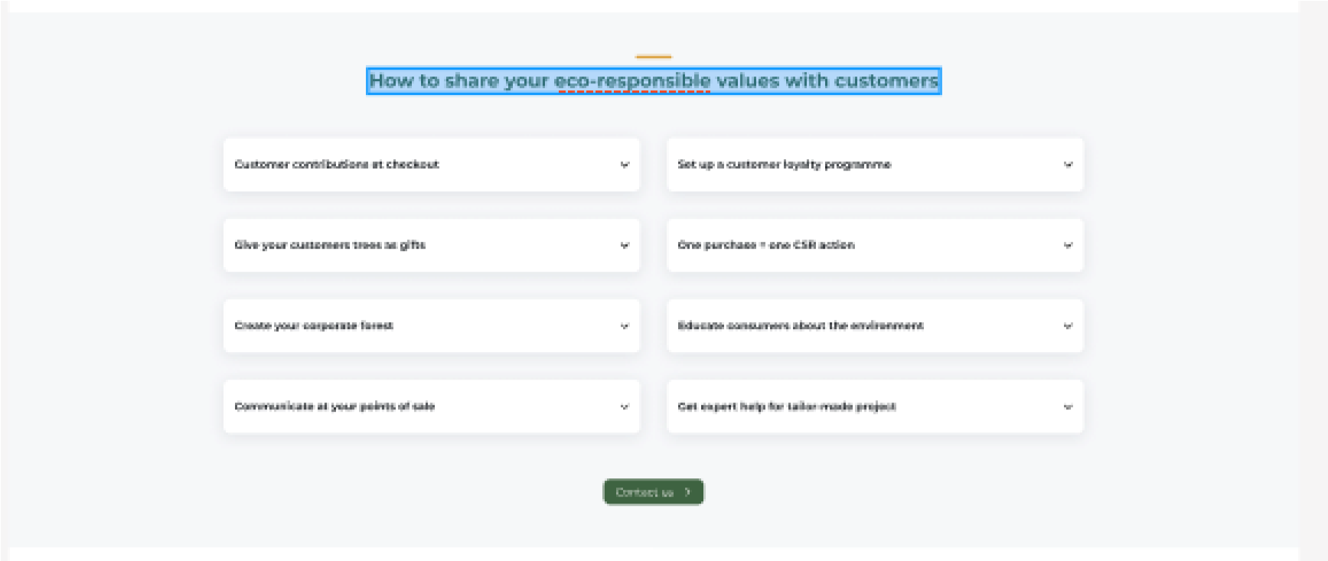

**Certified for quality**



**Footer**

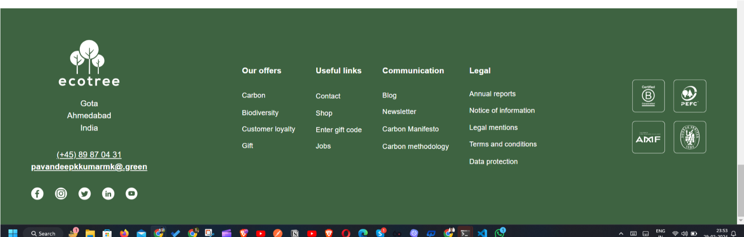

**Login Page**

